ENSF 480 Term Project Design

Melissa Picazo, Christina Lu, Michael Jeremy Olea

# Introduction

## Purpose

The software requirements in this document are for a Rental Property Management System (RPMS). A platform that is intended for users to browse and post property listings.

## Scope

The product is for landlords to post listing of their properties for renters to view. Renters will be able to use this product to search through rental listings. The system will have managers who will maintain the systems database and make changes to it when needed. This system will make it easier for people to advertise their properties as well as find properties for rent that fit their needs.

## References

ENSF 480 Term Project Fall 2019 – Document on ENSF 480 D2L

# Description

## Perspective

The RPMS design is server focused. To make it more accessible for users we must include an additional user interface for the clients. The database will handle all the back end while the user interface will handle the front end. It is important for the clients to easily understand how to use the product for it to reach its fullest potential.

## Features

The key elements of the system are as follows:

* Landlords will be able to register their properties after logging in. They must pay a fee to post their listing online for renters to view – these listings are active for a fixed amount of time, after which the listing will be suspended, and the landlord can choose to renew or remove their listing
* Renters can search through listings without making an account or logging in - Searches can filter the following aspects:
  + property type
  + number of bedrooms
  + number of bathrooms
  + furnished/unfurnished
  + city quadrant (NE, NW, SE, SW)
* Renters can choose to become registered renters by logging in. This feature will allow renters to save their search criteria and be notified when listings that match their criteria are posted. They can choose to opt out whenever they choose
* Renters can send an email to arrange a meeting with the Landlord if they are interested in the property – they will not be able to see any of the Landlord’s information
* Managers can login to set or change the amount and period of fees. They also have full access to the renters, landlords, and properties information via the database system
* Managers can also ask for a periodical summary report containing the following:
  + Total number of properties listed (including those that are no longer active)
  + Total number of properties rented
  + Total number of active listings
  + List of properties rented out (landlord’s name, house ID, address)
* Managers and Landlords can change the state of a listing, from active, to rented, cancelled, or suspended at any time.

# Operating Environment

The product will be hosted on a computer.

# Use Case Diagram

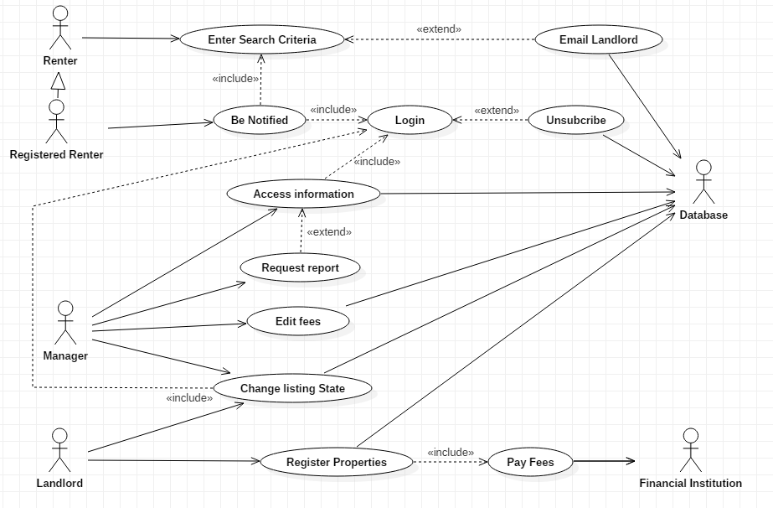

# Sequence Diagrams

## Register Properties

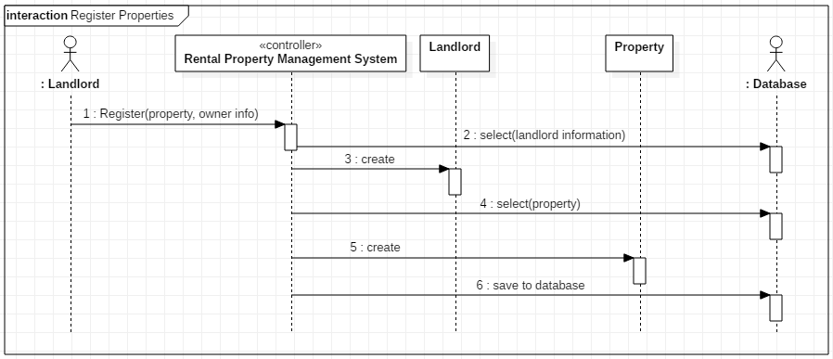

## Make Payment

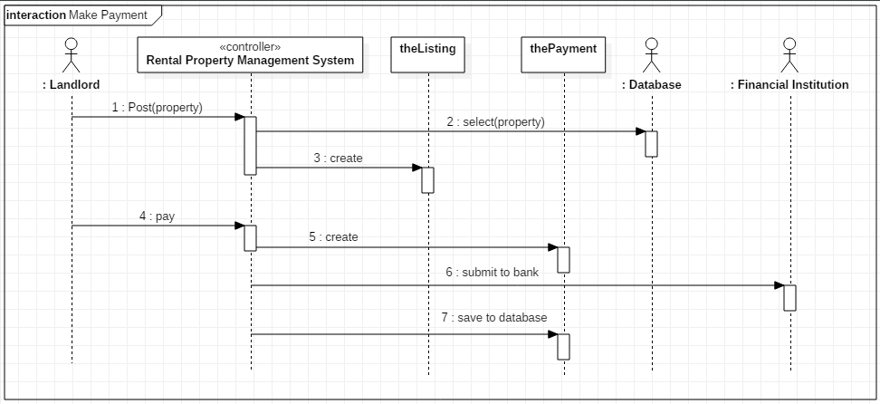

## Login

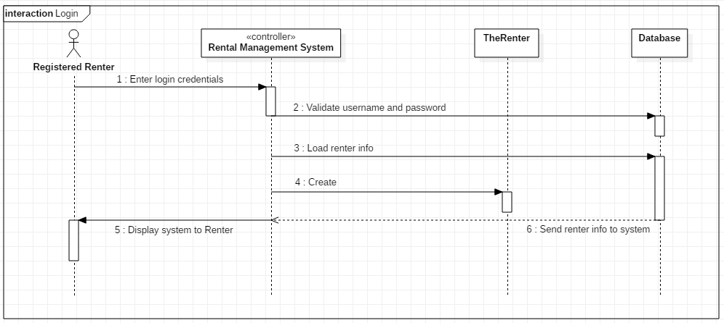

## Request Report

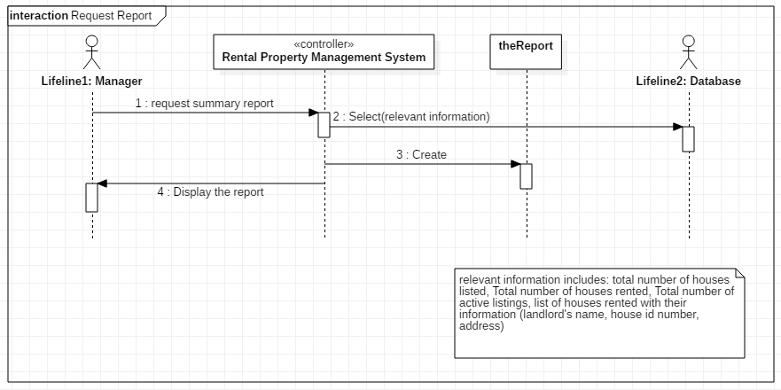

# State Transition Diagrams

## Property

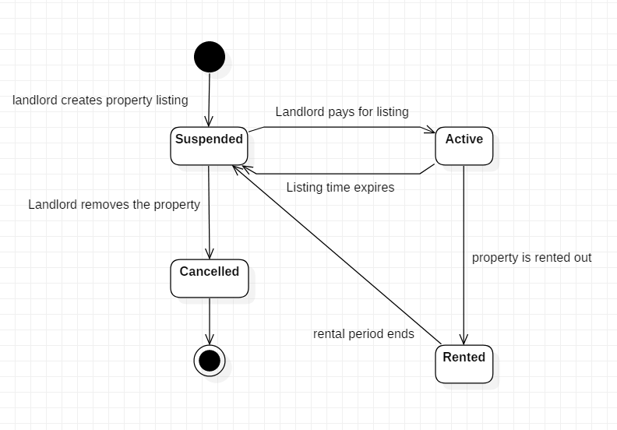

## landlord posts his/her property

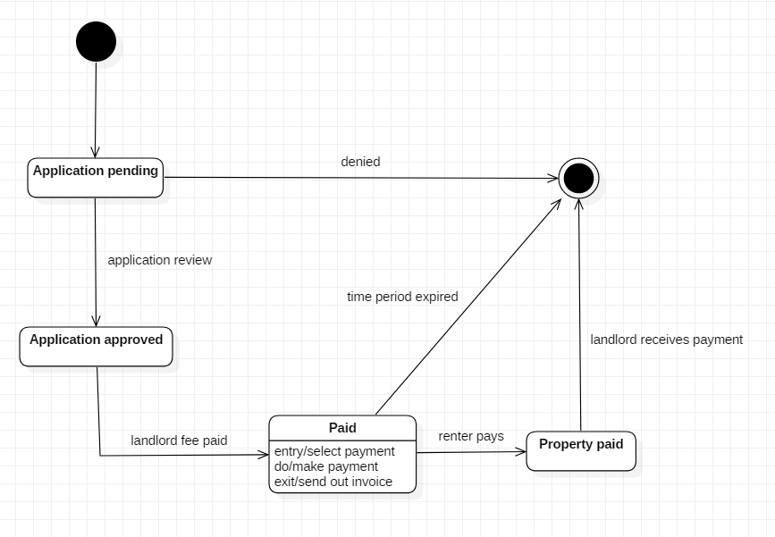

## Payment

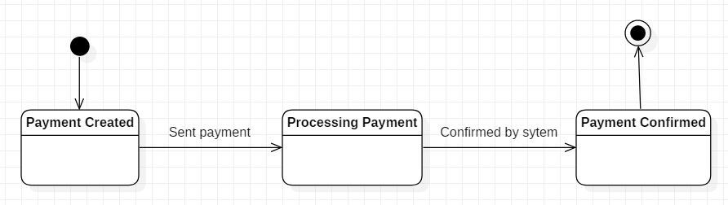

## Landlord registers property

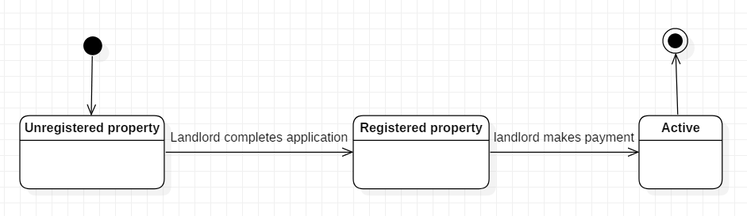

# Activity Diagram

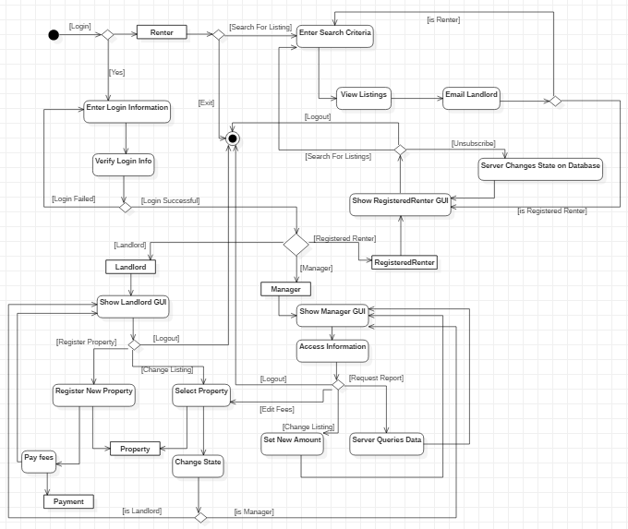

# Simplified Class Diagram

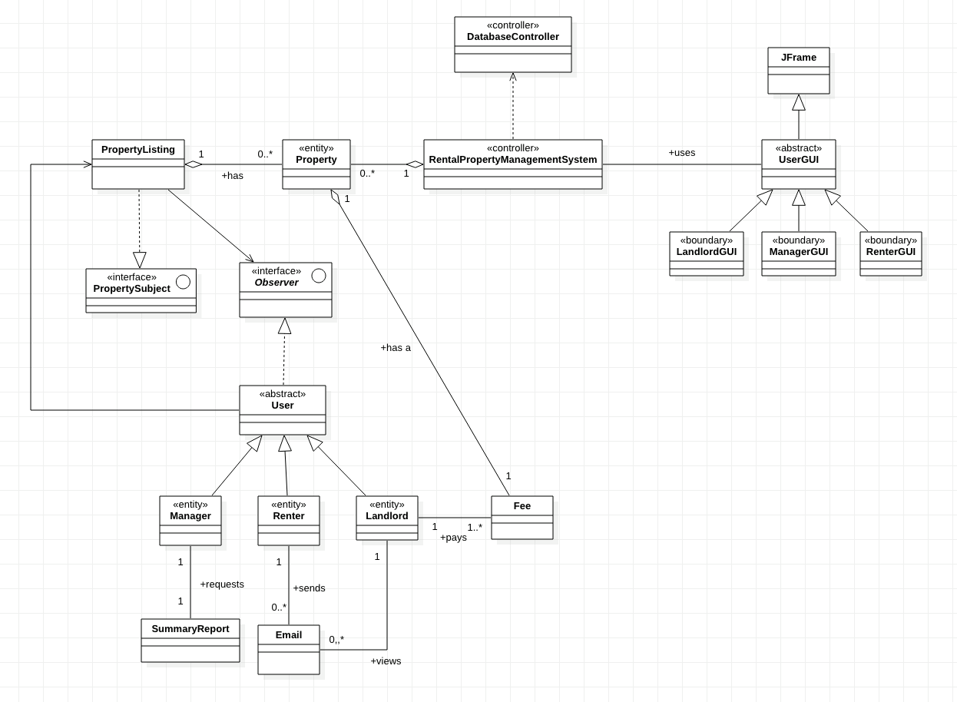

# Package Diagram

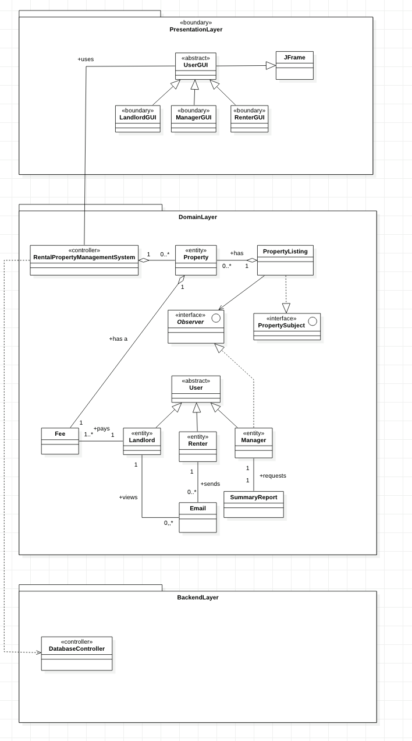

# Class Details

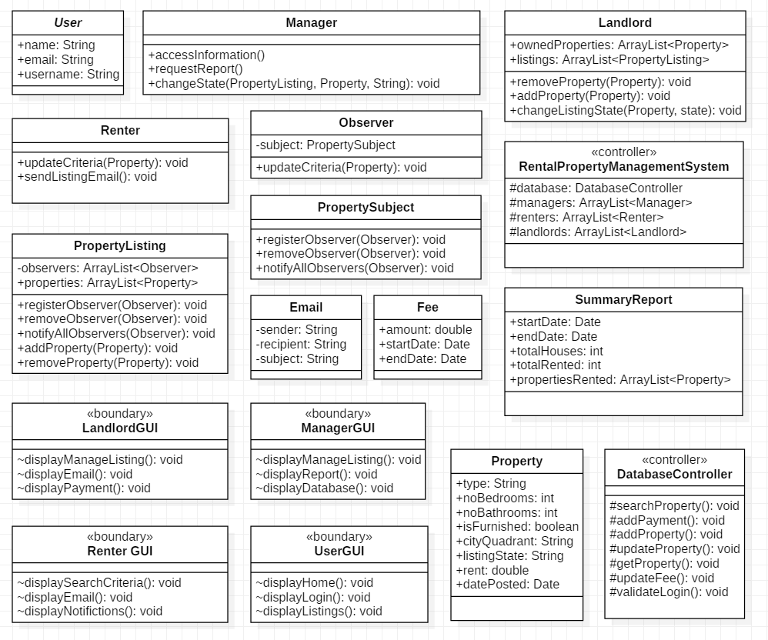

# Deployment Diagram

